Budget Rent-a-Car
of British Columbia

Location Control Tutorial

Version 1.03

Note: The information contained in this document is confidential and may not be disclosed to any parties outside of Budget Rent-a-Car of British Columbia Ltd. without written consent by one of its officers.

Copyright (C) 2009 Budget Rent-a-Car of British Columbia Ltd.
Table of Contents

1 Overview 1
2 Creating a Location 2
Entering General Information 2
Entering Address and Hours of Operation 4
Authorizing Drop off Locations and Charges 5
Defining Rates for Each Vehicle Class at the Location 7
Allowing the Opening and Closing of Contracts for Other Locations 9
Customizing the Broadcast Message 10
3 Making Changes to a Location 11
Retrieving a Location 11

1 Overview

Location Maintenance is a powerful module is GIS that allows you to control and maintain location-dependent information, such as address and hours, location-specific fees and fuel prices, drop of charges etc. You can also define different reservation and walk-up rates for all vehicle classes available for rent at each location. Location Maintenance not only allows you to edit your location’s information but also add in new locations as your business grows. Any information you define here will automatically kick in as you select the pick up location in your reservations and contracts.

Five tabs are used to classify the information on Location Maintenance.

General: This screen lets you enter basic information about the location, which also means that the information here varies by location.

Address/Hours: Contains the location address and hours of service.

Drop Off Location: Here, you define drop off locations and their associated charges.

Vehicle Class Rate: You may assign rate and level to each vehicle class for walk up customers at the location and reservations for that location.

Others: This sub-screen allows you to restrict which location(s) you may open a contract for and which location(s) you may close a contract for. You can also set different broadcasting messages for different locations through this tab.

2 Creating a Location

Entering General Information

Select Rate Control from the menu and click Location Maintenance to bring up the screen (See Figure 1). First and foremost, enter the name of your new location in the Location field. In the As of Date field, you can define the date your location’s information will be valid from. Populate the Owning Company, Manager and Wizard’s Corporate ID (a maximum of 4 numeric digits) fields as required. Populate the remaining fields with reference to the following table.

Rental Location | Specifies whether the location rents vehicles. If this flag is selected, you must populate the Mnemonic Code for Maestro, Member of Hub, Grace Period, Gasoline Fuel Price, Diesel Fuel Price, FPO Gasoline Price and FPO Diesel Price fields. You must also define at least one vehicle class and a valid rental period.
Allowed ResNet Reservation | Specifies whether ResNet takes reservations for the location.
GIS Member | Specifies whether the location is using the GIS system.
Allow Make Res For Others | Specifies whether this location can make reservations for other locations.

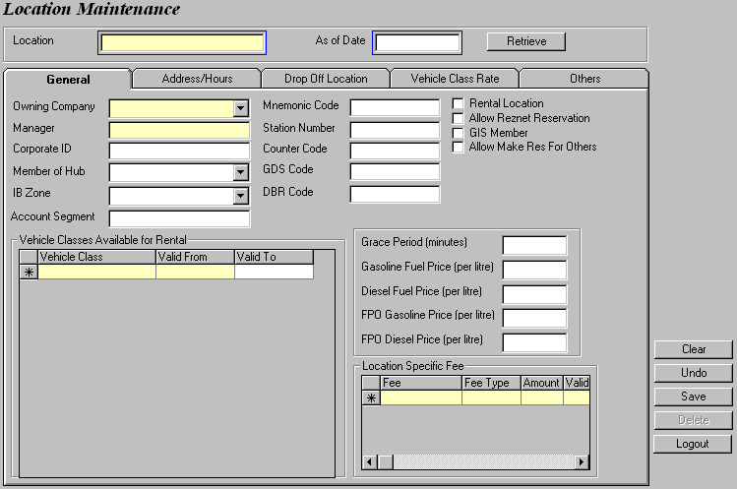
Figure 1: The Location Maintenance screen.
NOTE
For all locations belonging to your company, select ‘Local’ from the IB Zone field. There are also three other types of IB Zone:

  - Lower Mainland

This includes all rental locations in the lower mainland, i.e. Vancouver, Burnaby, Surrey, Coquitlam, Richmond, Langley, White Rock, Chilliwack, Maple Ridge.

  - United States

This includes all rental locations in Seattle and Bellingham.

  - BC/Alberta/Abbotsford/North Van

All rental locations in Abbotsford, North Vancouver and Alberta belong in this zone. Any city within British Columbia not covered in the Lower Mainland zone also belongs here.

NOTE
The Account Segment field must not be left empty if your accounting is based on location.

Account numbers in GIS are structured into three levels, as shown below.
Account Number
Vehicle Class Segment Number
Location Segment Number

NNNNN—XX—YY

So let’s assume that you base your accounting on location. If you enter ‘10’ in the Account Segment field for your location, then the revenue for, say baby seats (Account 7003) rented at that particular location will go into account number 7003-10.

You may also specify any special fees that are automatically charged to the customer if s/he picks up a vehicle at certain locations in the Location Specific Fee section. The fees can be defined as a flat, percentage or daily amount.

Let’s create a rental location called ‘A-01 Burnaby’ that has every single vehicle class for rent. This location allows for ResNet reservations and is also able to make reservations on behalf of other rental locations. After defining the grace period and fuel prices, set the Energy Recovery Fee, Vehicle Licensing Fee/Air-Conditioning Tax and a 5% Location Fee as your location specific fees. Your final screen should look like Figure 2 and you are ready to switch to the next tab.
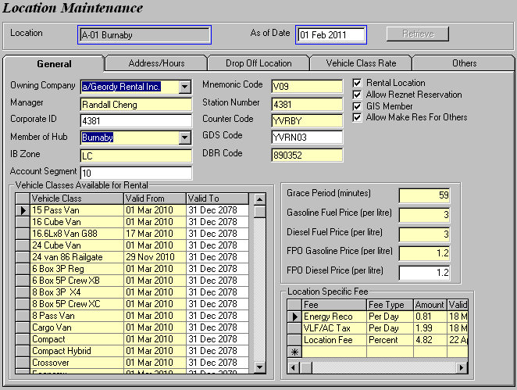
Figure 2: General information for the Burnaby rental location.

Entering Address and Hours of Operation

Switch to the Address/Hours tab to enter your location’s exact contact information and business hours (See Figure 3). The Location Name field displays the name of your location in any confirmation/cancellation email that is sent out when a reservation is made for that location, see Figure 4.

The Address and Phone # will be printed on all your rental agreements, receipts, reservation confirmation/cancellation emails and any letter template GIS has in store (e.g. parking ticket letter). The Hours of Service section controls the pick up and drop off time when you make reservations or open a contract for the location.

The Address Description and Hours and Closures Description are used for display at the bottom of the Reservations screen, as shown in Figure 5. These information are generally used for describing the location and hours to the customer. Similar to Location Name, the Hours Description (Email) field displays the business hours of the location in any reservation confirmation/cancellation email (refer back to Figure 4).

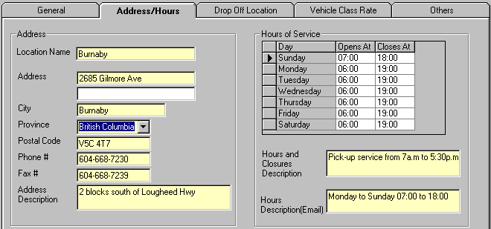
Figure 3: The Address/Hours sub-screen.

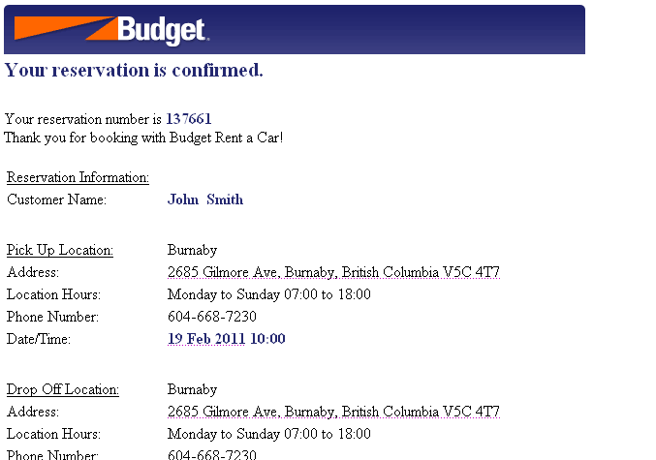
Figure 4: The location information in the confirmation email is controlled through Location Maintenance.
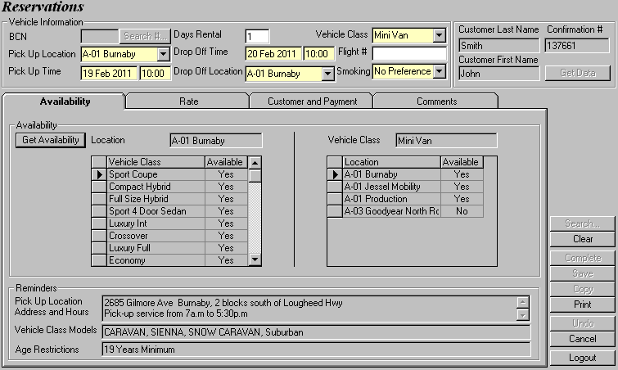
Figure 5: The Reminders section shows the address of the pick up location and brief descriptions of the address and service hours.

Authorizing Drop off Locations and Charges

The purpose of the Drop Off Location screen is to define the drop off locations for all rentals if a vehicle is picked up at this location, which in this case, Burnaby. For each drop off location you select, you must also specify whether or not it is authorized and the associated charges. We will explain these terms later but first, let’s add a couple of authorized locations and throw in Vancouver Airport as the only unauthorized locations (See Figure 6). Set the respective charges as well as the valid dates.

You would also have to specify a Default Unauthorized Charge for all locations that are not individually selected.
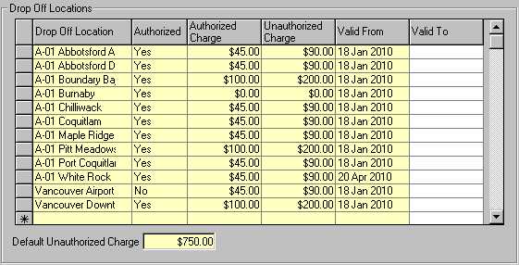
Figure 6: Defining drop off locations, its respective charges and validity.

If you authorize a location as the drop off location, it will show up in the Drop Off Location list in Reservations and Contract Open/Check Out screens (See Figure 7). As you check in your vehicle, GIS will verify the location where the vehicle is returned to and refer to the Drop Off Locations grid in Figure 6 to determine whether or not the location is an authorized location. If it is, then the corresponding Authorize Charge will be added to the rental charges.

On the other hand, if a drop off location is not authorized, like the Vancouver Airport location we previously mentioned, it will not be displayed in the Drop Off Location list when you open a contract or make a reservation. If the vehicle is checked in at an unauthorized drop off location, the Default Unauthorized Charge (can be overwritten by the Unauthorized Charge), then it will be added to the renter’s bill. In our example, if a vehicle is picked up at Burnaby and returned to Vancouver Airport, the renter will be ask to pay an additional $90 for the unauthorized drop off charge.

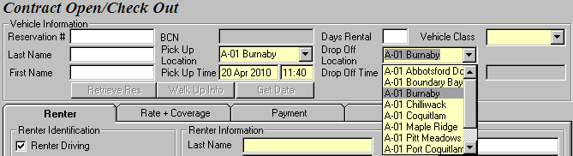
Figure 7: The Drop Off Location list displays all locations that are authorized in Location Maintenance.

Defining Rates for Each Vehicle Class at the Location

In the Vehicle Class Rate sub screen, you can assign rates and rate levels for each vehicle class which is picked up at the specified location. GIS can accommodate different rates on different days. You can also assign multiple rates for a vehicle class on each day. Each rate-level combination is also assigned a selection type (See Figure 8) which identifies the nature of the rate.

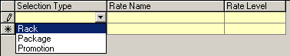
Figure 8: Three selection types for rate.

This screen provides five scenarios in which you might want to set your rates differently:

- Walk Up
- Reservation Same Day
- Reservation Future Day
- Reservation Same Day & Future Day
- Walk Up & Reservation Same Day

Switch to the All (Date set) sub tab. On the right hand corner of the screen, select the Reservation Same Day option to customize the rate offered in the Reservations screen. The For Use From field defaults to the current date.

NOTE
We omit the Walk UP (1 Day) and Reservation Same Day (1 Day) tabs because their functionalities are duplicated in the All (Date set) tab.

Select a Vehicle Class (let’s use a Full Size 4Door) and click Retrieve. Assuming that no rates have been set for your selected vehicle class on the For Use From date, GIS will pop up a warning message (See Figure 9), indicating that it cannot find any rates for your selected vehicle class. This is fine. Click OK to close the warning message and the Rate by Vehicle Class grid will be enabled.

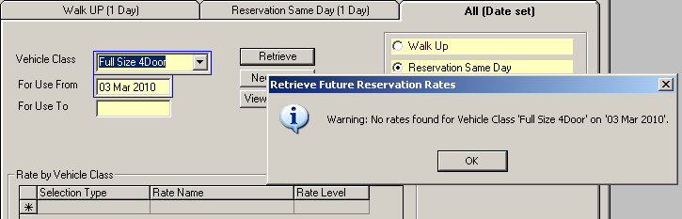
Figure 9: A warning message appears when first setting rates for a vehicle class.
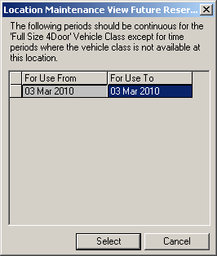
Enter the current date in the For Use To date field. Now, select ‘Rack’ from the Selection Type drop down and enter the Rate Name and Rate Level using ‘D45’ and ‘B’ respectively. Save your changes. You can always check the valid time periods you have assigned to your vehicle class by clicking the View Periods button, as shown in Figure 10.

In GIS, rates are normally assigned in Location Maintenance on a daily basis. However, if you prefer to set rates for a specific time period, you may do so by clicking the New Period button after specifying the vehicle class and dates of usage.

Figure 10: This window records all dates where the vehicle class is assigned a rate.

NOTE
If rates are entered for a vehicle class then one and only one of the selection types must be ‘Rack’. There is no restriction for ‘Package’ and ‘Promotion’.

In the Reservations screen, you will see that D45 is retrieved immediately after specifying the rental information and clicking Get Data (See Figure 11). This default rate that is assigned to the reservation is the rack rate.

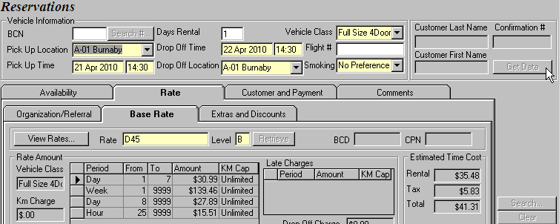
Figure 11: Click Get Data to automatically retrieve the rack rate in the Reservations screen.

Having only one rate selection for the Full Size 4Door seems a little boring. Let’s add two special package rates to it, as shown in Figure 12. Save your changes. Now when you click Get Data in Reservations, D45 will still be pulled up first since it is the rack rate. However, you will be able to see the two package rates we just added for the Full Size 4Door by clicking on View Rates on the Rate sub screen, as shown in Figure 13.

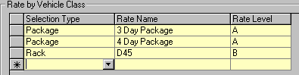
Figure 12: Assigning multiple rates for a vehicle class.

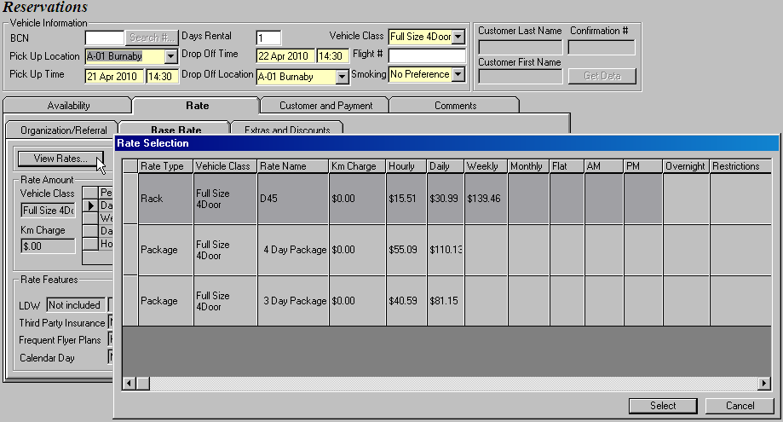
Figure 13: Clicking on View Rates allows you to see all available rates for the selected vehicle class.

What if we want D45 to also be automatically offered to a walk up customer who rents a Full Size 4Door at the Burnaby location? Easy. Just select ‘Walk Up’ on the right hand corner of the screen and follow the same steps as mentioned above.

Allowing the Opening and Closing of Contracts for Other Locations

This screen allows you to specify which rental locations your Burnaby location can open and close contracts for. You might not get used to this idea at first since it is only logical that your location can only check out vehicles which are parked at your location and check in vehicles that are returning to your location. Why would, for example, your Burnaby location close a contract for a vehicle that is returned to Vancouver? It makes no sense.

Well, not quite. If your location happens to serve multiple locations because of the close proximity, or if your location shares the fleet with several other locations, then it would make sense for your location to be able to open and close contracts on behalf of other locations. Then why didn’t we use the same location name for all these rental locations? By splitting the locations, we can correctly and conveniently identify the revenue for each individual location. You should not forget that it is also easier to customize location-specific information such as rates and special fees for different locations rather than merge multiple locations into one.
For our Burnaby location, we would want to be able to open and close contracts for the Jessel Mobility and Production rental locations. So go ahead and add these two locations into the Selected Pick Up Locations in Group column (See Figure 14). Save your changes.

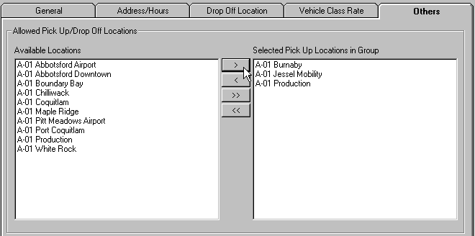
Figure 14: Selecting the rental locations your specific location can open or close contracts for.

Customizing the Broadcast Message

We are now at the last step of adding a location. In the same Others sub screen, add a message in the Broadcasting Message section at the bottom of the screen. This message will only be seen by all employees who log into the Burnaby GIS. A few seconds after you save your changes, the broadcasting message will be displayed repeatedly, as shown in Figure 15.

Figure 15: The message is broadcasted non-stop at the bottom of your GIS screen.

3 Making Changes to a Location

Retrieving a Location

Bring up the Location Maintenance screen by selecting it from the Rate Control menu. Enter the Location name and click Retrieve. If you also enter a date in the As of Date field, GIS will bring up the location information that is valid as of that date.

If more than one match is found when a location is searched for, then a list containing the location name, owning company and city will be displayed to the user for selection.

